# Lesson 54 单词讲解

1. sticky adj. 粘的

sticky fingers 黏糊糊的手指sticky weather 闷热的天气stick v. 粘贴

1. persuade v. 说服，劝说

persuade sb. (not) to do sth.

persuade sb. into / out of doing sth.

1. mess n. 乱七八糟

What a mess!

把某个东西弄得很乱

make a mess (of …)

东西处于混乱的状态

be in a mass

Your bed room is in a mass

1. sign v. 签字

sign your name here signature n.签名sign a contract

n. 指示牌，符号

1 sticky ['stiki] a.粘的

2 finger ['fiŋgə] n.手指

3 pie [pai] n.馅饼

4 mix [miks] v.混合，拌和

5 pastry ['peistri] n.面糊

6 annoying [ə'nɔiiŋ] a.恼人的

7 receiver [ri'si:və] n.电话的话筒

8 dismay [dis'mei] v.失望，泄气

9 recognize['rekəgnaiz] v.认出，听出

10 persuade [pə'sweid] v.说服，劝说

11 mess [mes] n.乱七八糟

12 doorknob ['dɔ:nɔb] n.门把手

13 sign [sain] v.签字

14 register ['redʒistə] v.挂号邮寄

# Lesson 54 课文&语法讲解

1. After breakfast, I sent the children to school and then I went to the shops.
2. The children were at school, my husband was at work and the house was quiet.

在上学 在上班

1. In a short time I was busy mixing butter and flour and my hands were soon covered with sticky pastry.

be busy doing sth. be covered with …

flower 花 / flour 面粉

1. Nothing could have been more annoying.
2. I picked up the receiver between two sticky fingers and was dismayed ... pick up / hang up 捡起来/挂掉
3. It took me ten minutes to persuade her to ring back later.

打电话打回去

To do sth takes sb. some time

= It takes sb. some time to do sth.

1. At last I hung up the receiver.

8.What a mess!

1. There was pastry on my fingers, on the telephone, and on the doorknobs.
2. I had no sooner got back to the kitchen than the doorbell rang loud enough to wake the dead.

no sooner … than …（38课）

一．。就

enough

adj.I have ~ time/time ~. adv. good ~

the + adj. 表示一类

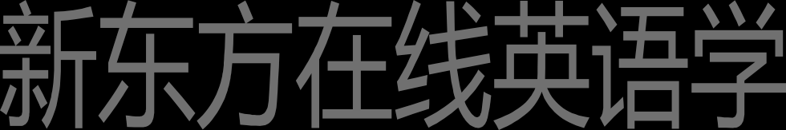the dead the living the rich the poor

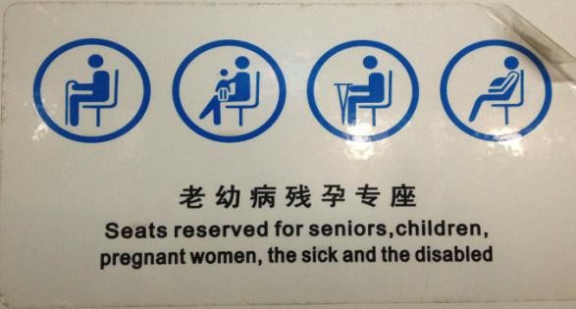

# Lesson 54 知识拓展

补充内容:

I go to school.

去上学

可数名词单数 前面有a the 表示抽象 所以这个school 翻译成上学

I go to the school to pick up my friends.

前面有限定名词了the 就表示去学校

I sent the children to school. The children were at school …

补充内容:

They went to church. They went to the church.

补充内容:

He went to hospital.

He went to the hospital to see someone.

